EXP 3: Multi-Byte Data and Array Operations Using 8086 Indirect Addressing
- To add two 32-bit (double-precision) numbers using register-indirect and based addressing with SI, DI and BX.
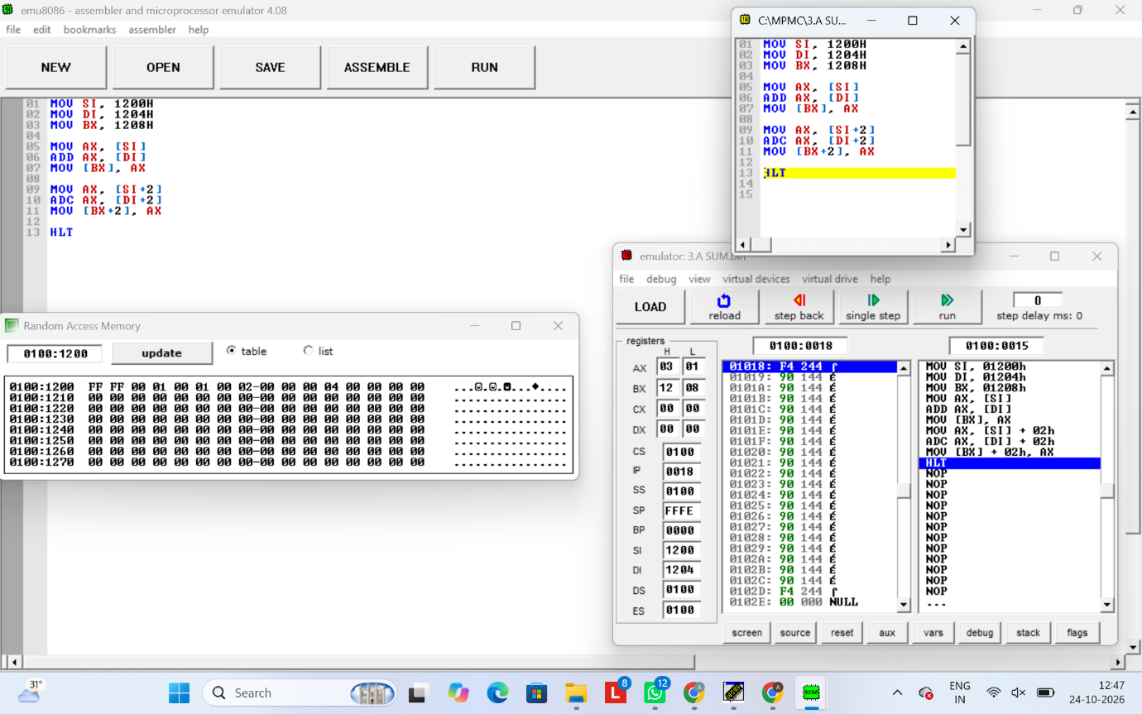
b). To find the sum of N 16-bit numbers stored in a word array with a 32-bit result using a loop.


